Ramadan Monday 09/04/2024

Lesson 140 and 141

Why is Rebasing Scary? Is it?

<https://www.canva.com/en_gb/login/?redirect=%2Fdesign%2FDAEVkyNcwWI%2Fqt8pRN3JA1lP9ckYeImxeQ%2Fview>

A collegue that worked on master and He merge into master maybe by pull request or something.

How do I get the new work commit onto my feature branch?

This is not a fast forward merge.

I continue more work and a coworker adds new work to master. I need to get those commits on my future branch

I need to continuously merge to it.

There might be lots of merge due to activeness of the master. Everybody need to get changes to their feature branches. Too much of merged commit in the history that are not informative.

I think the rebase is to get rid of merge histories.

<https://git-scm.com/docs/git-rebase>

Lesson 143

Rebase Demo Pt 1: Setup & Merging

On feature branch

This is what im doing below

I will add footer gi

I want to keep working on my feature branch but want to get all the changes from master branch. I can merge master inside feature.

Switch to feat

Now I want to merge in changes from master.

I have gotten the work from master to the feature now.

Let say I have been working on this for like half a day and I need to go back to master.



This is master more people added login on master

I also want to add login form into the feature branch. I can go into feature branch and merge master into feature. There is a commit that I don’t have

The login form in the master has been merged into the feature

So far I want to keep getting upto date information from master you I need to keep merging to the feature and more of merge branch will be in the log history.

On a really larger project it will be nice to have a more friend command like rebase

10/04/2024 Eid day Ramadan Wednesday

I have the feat branch and I have merged twice from master. My master branch does not have any of the feat work.

Rebase command is re-writing history. If I rebase I get new commit generated

Rebase command is re-writing history Rebase will take the feat branch commit, create new one that are based on the original and put them all at the tip of the master branch. The commits on the feat branch will not be destroyed but will be recreated

I am merging before rebasing, you can also rebase instead of merging

Rebase clean up my history

Example 2

I can use rebase instead of merging.

Im want what I just did on master to be on my feat branch. Instead of merging I will rebase.

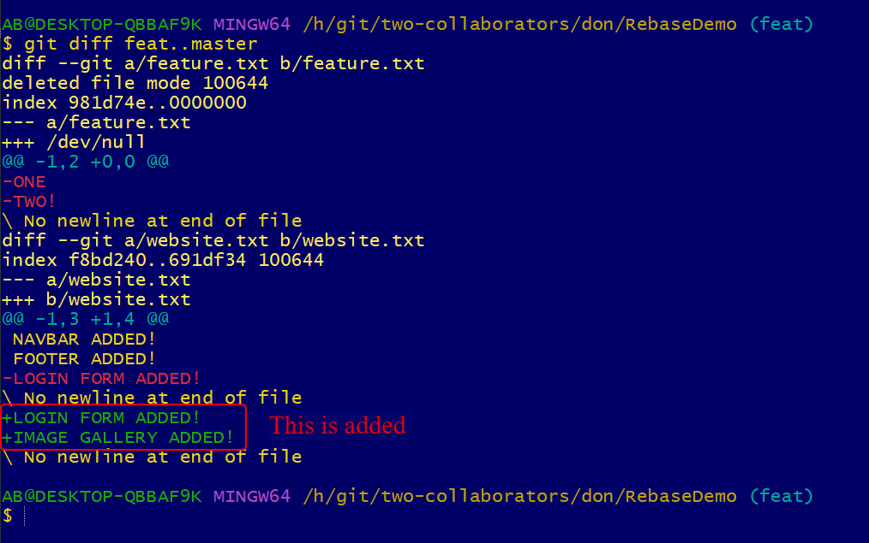

You can keep merging but when you finish you can rebase before show it to people .

Lesson 145

The Golden Rule: When NOT to Rebase

I don’t change my master branch, I only change my commits on feature branch. I am only changing on my feature branch not on master

Lesson 145

Handling Conflicts & Rebasing

Will switch to master now

Switch back to feat branch

I want to rebase instead of merge now.

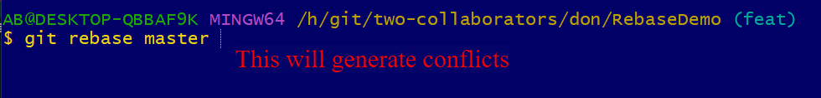

Conflicts, I need to go to the file and do the partial rebase



Run that command

